Redes ITPA

Edificio A.

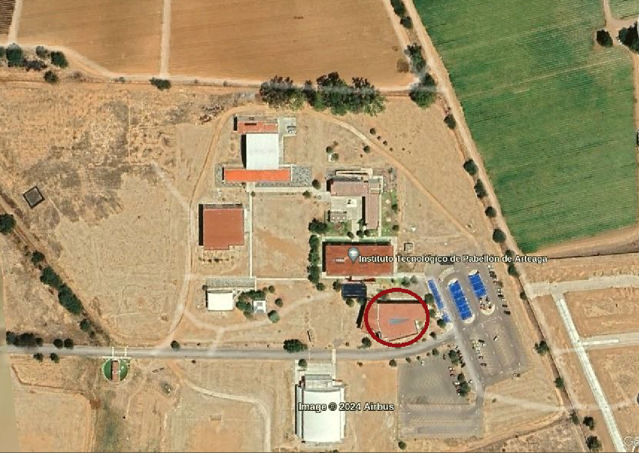

|  |  |  |  |  |
| --- | --- | --- | --- | --- |
| Edificio A | | | | |
| Planta alta | | | | |
| Redes | 2.4 | Frecuencia | 5 | Frecuencia |
| WifiAdmin | CH3, CH2, CH9 | 20MHz | CH149 (151), CH44(46), CH149(46) | 40MHz |
| Docentes | CH3 | 20MHz | CH149 (151) | 40MHz |
| Students | CH2 | 20MHz | CH149 (151) | 40MHz |
| Planta baja | | | | |
| WifiAdmin | CH5, CH10, CH7 | 20MHz | CH149(145) | 40MHz |
| Docentes | CH5 | 20MHz | CH149(151), CH36(36), CH36(38) | 40MHz |
| Students | CH9 | 20MHz | CH36(38), CH149(151) | 40MHz |
| Afuera | | | | |
| WifiAdmin | CH5, CH10, CH7 | 20MHz | CH44(46) | 40MHz |
| Docentes | CH5 | 20MHz |  |  |
| Students | CH9 | 20MHz |  |  |

Edificio B.

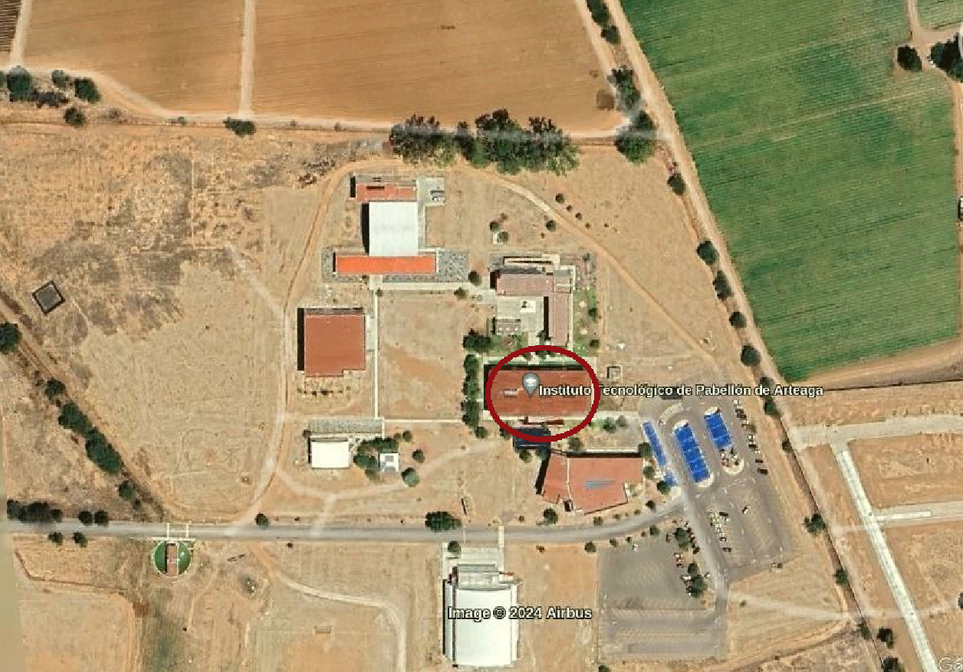

Edificio B (Abajo)

Frecuencia 2.4

Docentes (-2m)

Students (-3m)

WifiAdmi(39m)

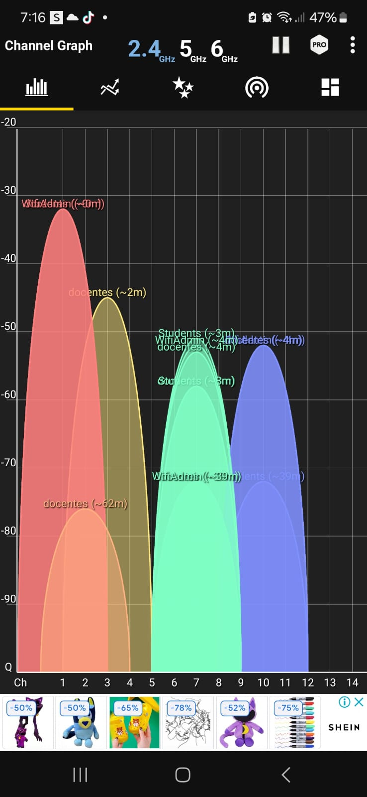

Frecuencia 5

Docentes (-17)

WifiAdmin (-4)

Students (-7)

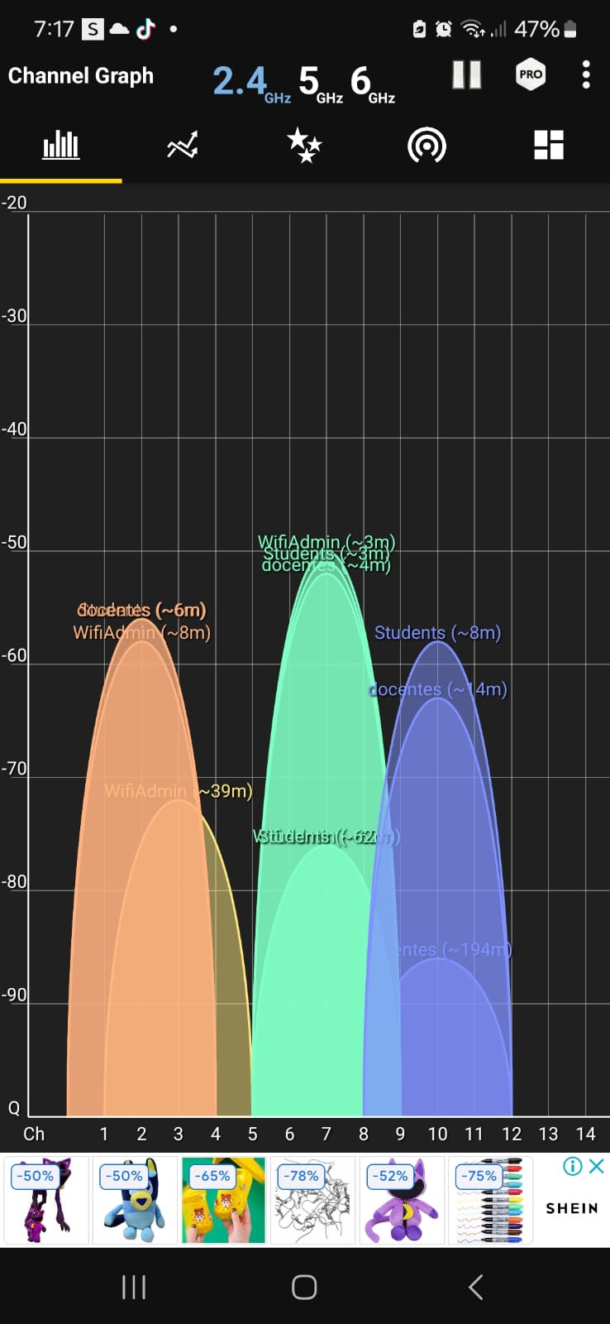

EDIFICIO B (Arriba)

Frecuencia 2.4

Docentes (-6m)

WifiAdmin (-8m)

Students (-6m)

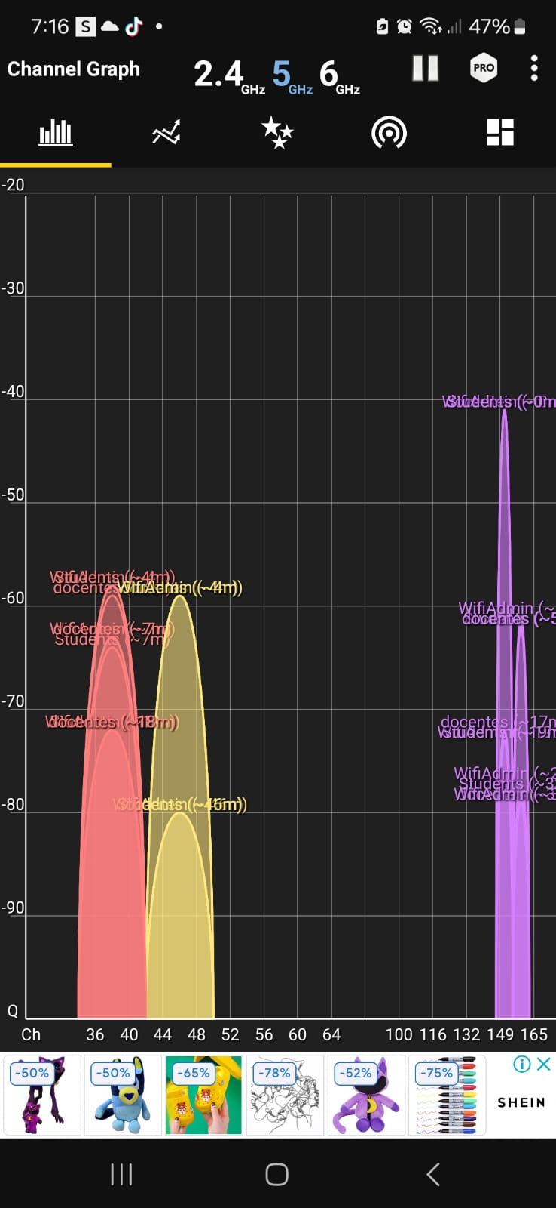

Frecuencia 5

Docentes (-23m)

Students (-33)

WifiAdmin (-8)

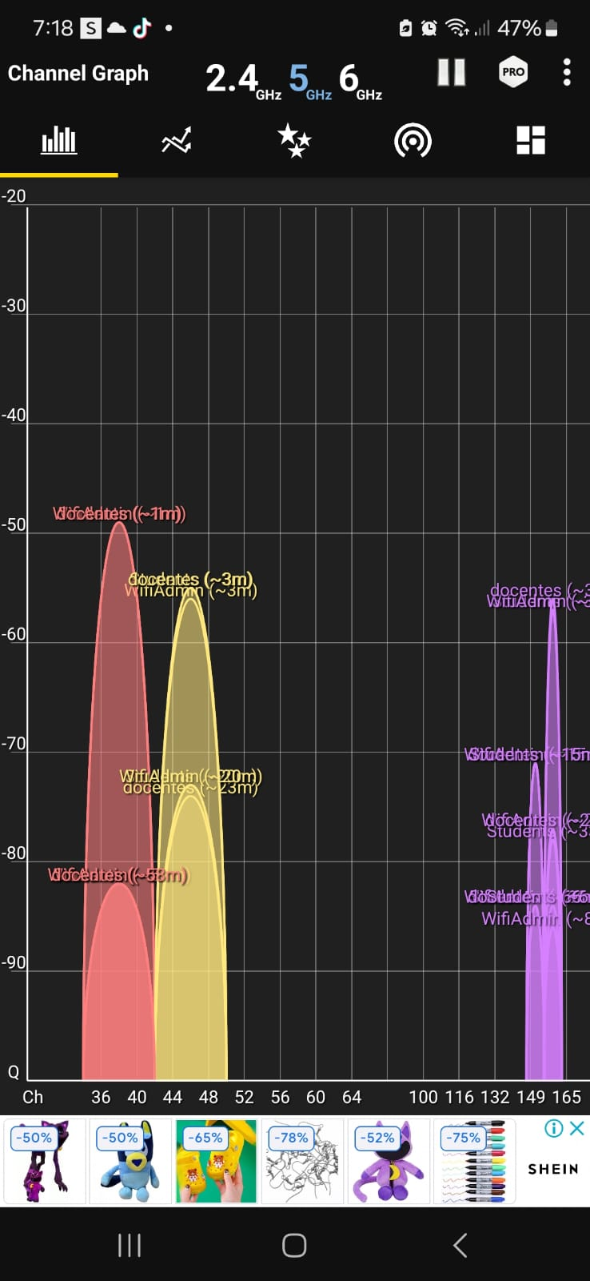

Frecuencia 6

Docentes (-73m)

Students (12m)

WifiAdmin (-14)

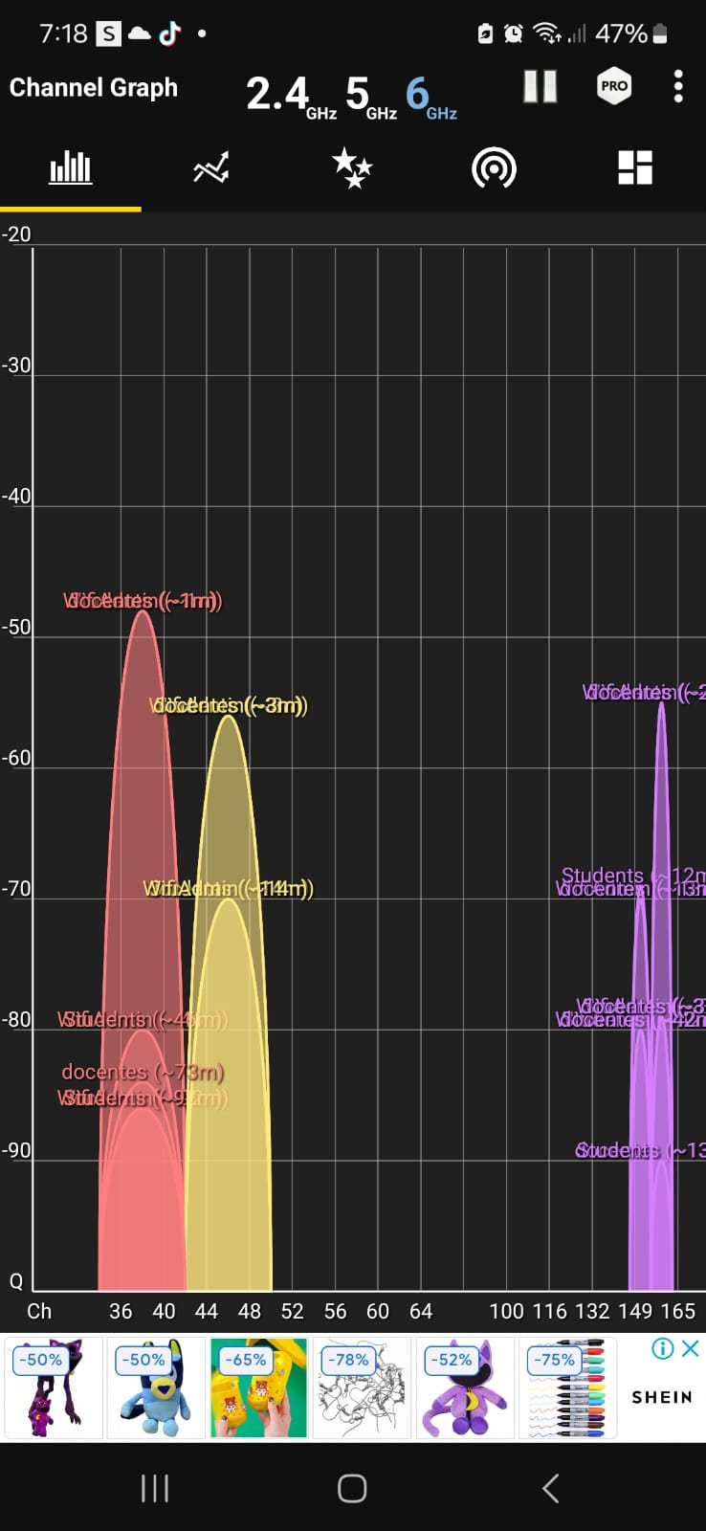

Frecuencia 5

docentes(-16m)

students(58m)

WifiAdmin(-16)

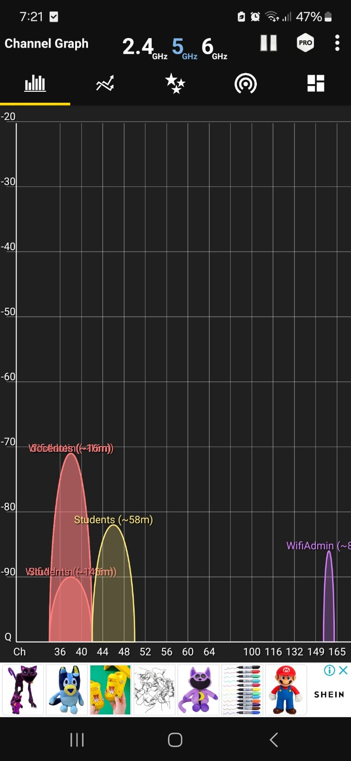

Edificio C.

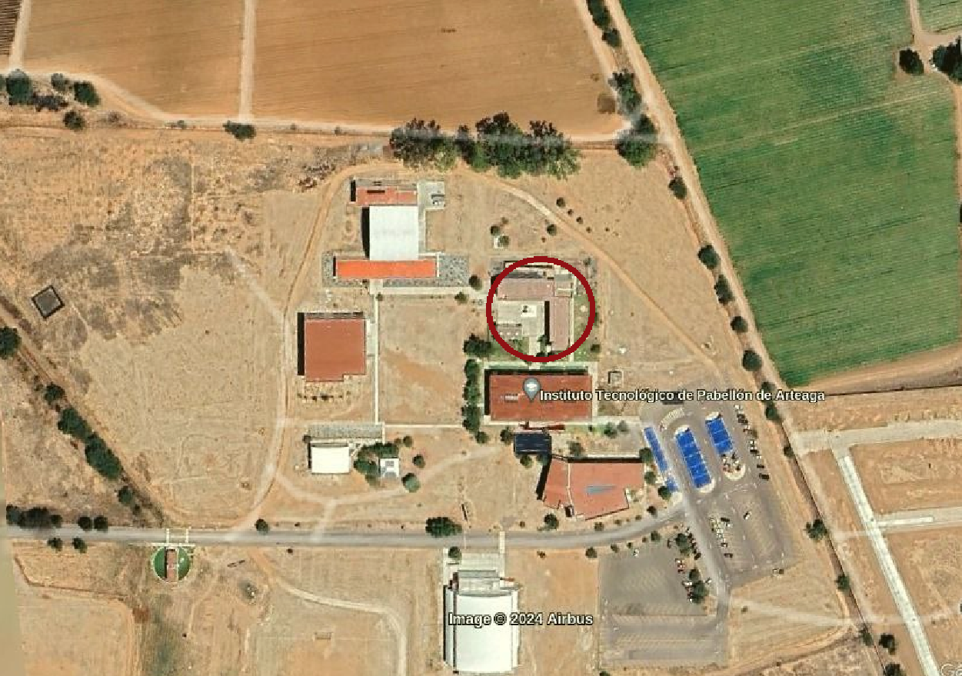

|  |  |  |  |  |
| --- | --- | --- | --- | --- |
| Edificio C | | | | |
| Planta Baja | | | | |
| Redes | 2.4 | Frecuencia | 5 | Frecuencia |
| WifiAdmin | CH1, CH5, CH11 | 20MHz |  |  |
| Docentes | CH5, CH9 | 20MHz |  |  |
| Students | CH3, CH5, CH11 | 20MHz |  |  |
| DIRECT-PT-BRAVIA | CH9, CH13 | 18MHz |  |  |
| Planta Alta | | | | |
| Redes | 2.4 | Frecuencia | 5 | Frecuencia |
| WifiAdmin | CH1, CH5,CH8 | 20MHz |  |  |
| Docentes | CH1, CH5 | 20MHz |  |  |
| Students | CH5,CH9 | 20MHz |  |  |
| LIA15 | CH3 | 18MHz |  |  |
| LIA_2 | CH8 | 18MHz |  |  |

Edificio D

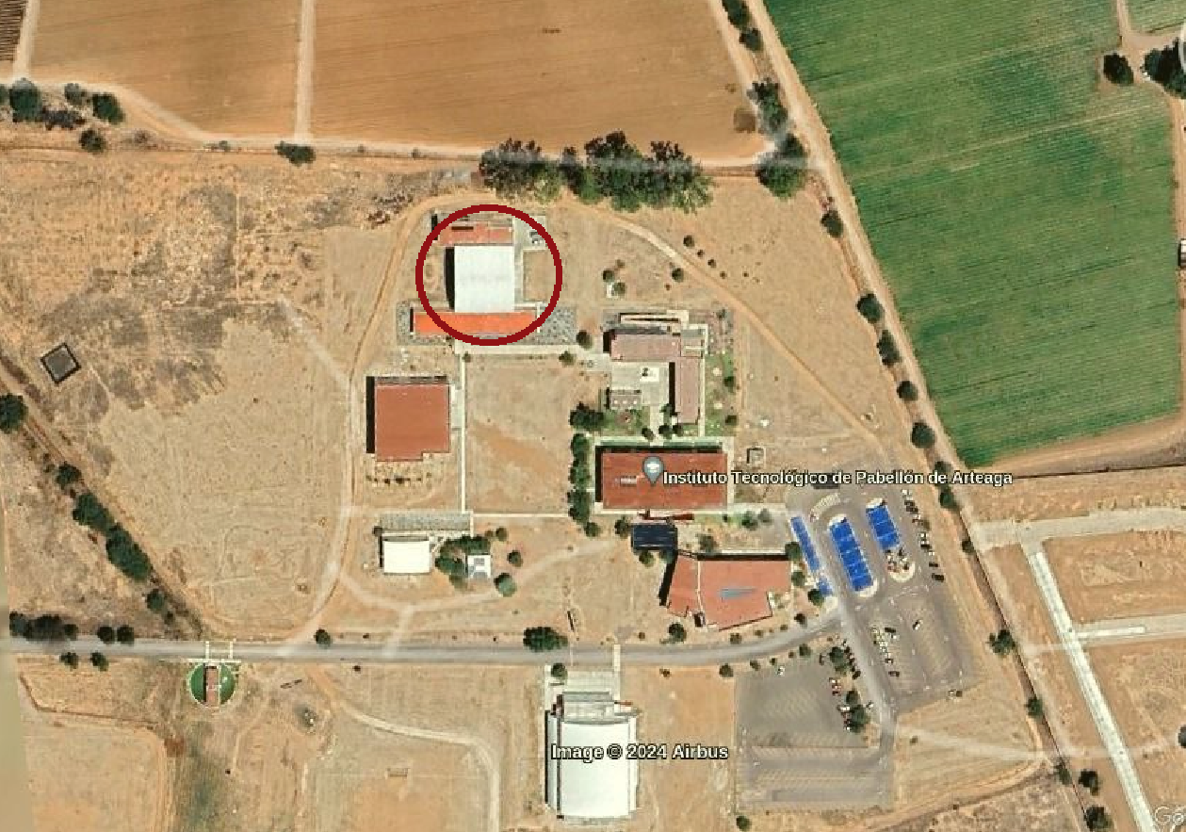

|  |  |  |  |  |
| --- | --- | --- | --- | --- |
| Edificio D | Afuera |  |  |  |
| Redes |  | 2.4 Frecuencia | 5 | Frecuencia |
| WifiAdmin | CH 44, 45, 46 | 40Mhz |  |  |
| Docentes | CH 7 | 20MHz |  |  |
| Students | CH 9 | 20MHz |  |  |
|  |  |  |  |  |
| Edificio D | Adentro |  |  |  |
| Redes |  | 2.4 Frecuencia | 5 | Frecuencia |
| WifiAdmin | CH 4 | 20Mhz | CH 157 | 40MHz |
| Docentes | CH 4 | 20MHz | CH 158 | 40MHz |
| Students | CH 4 | 20MHz | CH 159 | 40MHz |

Edificio E

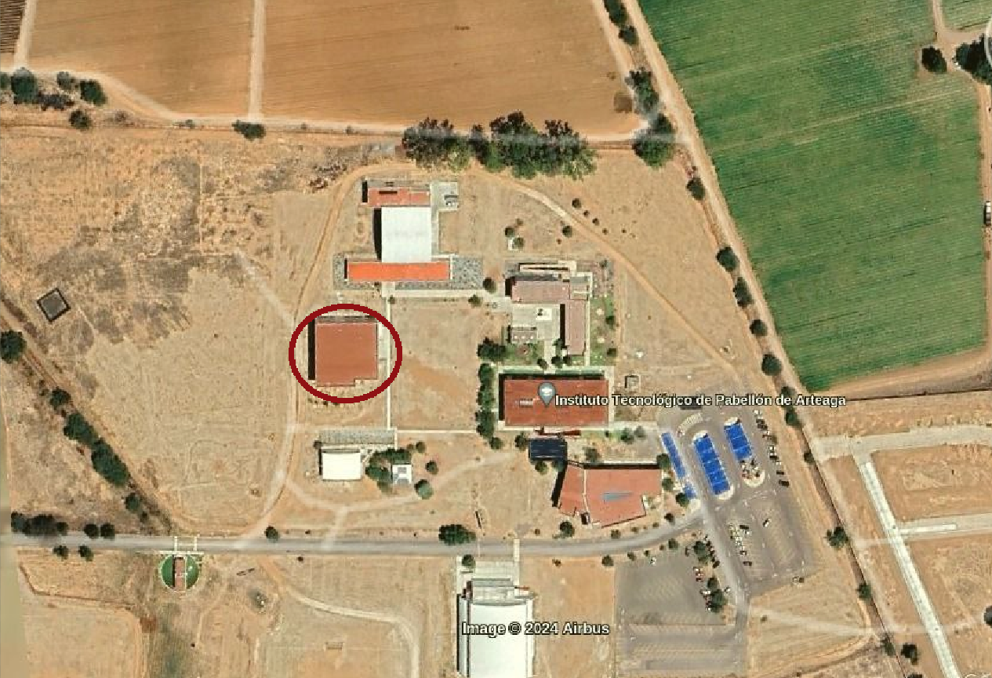

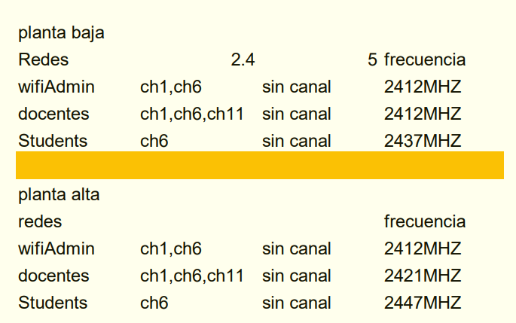

Poliforum.

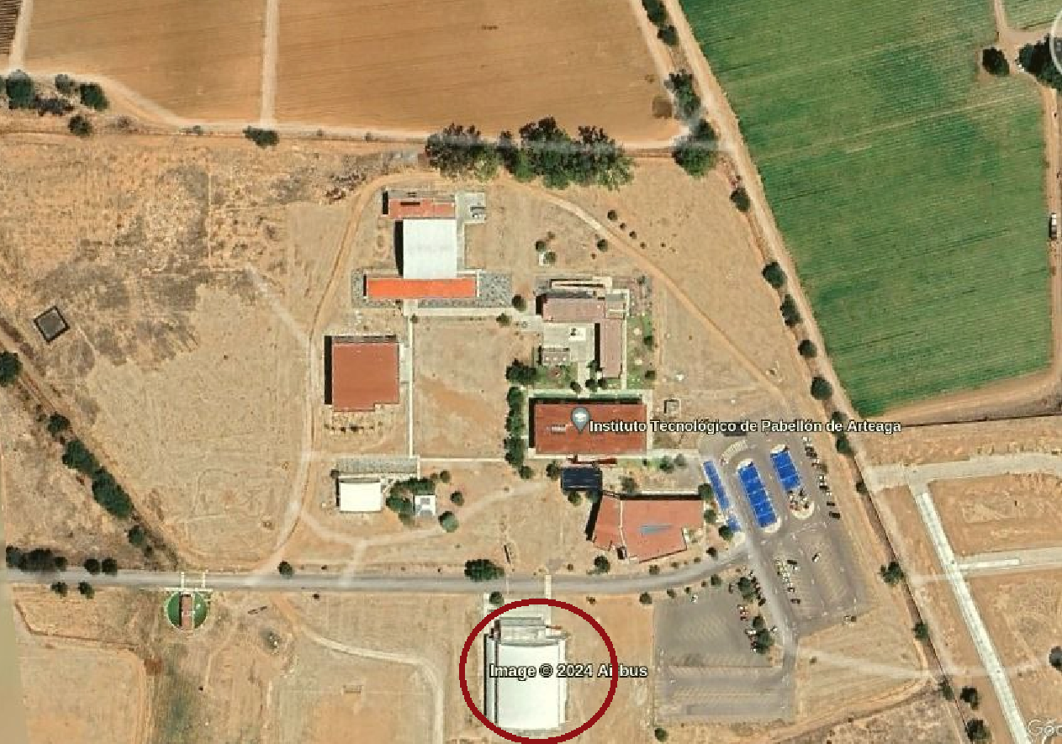

|  |  |  |  |  |
| --- | --- | --- | --- | --- |
| Poliforum |  |  |  |  |
| Planta Baja |  |  |  |  |
| Redes | 2.4 | Frecuencia | 5 | Frecuencia |
| poliforum | CH11 | 20MHz |  |  |
| Students | CH6 | 20MHz |  |  |
| Planta Alta |  |  |  |  |
| Redes | 2.4 | Frecuencia | 5 | Frecuencia |
| poliforum | CH11 | 20MHz |  |  |
| Students | CH6 | 20MHz |  |  |
| Afuera |  |  |  |  |
| Redes | 2.4 | Frecuencia | 5 | Frecuencia |
| poliforum | CH11 | 20MHz |  |  |
| Docentes | CH8 | 20MHz |  |  |
| Students | CH3 | 20MHz |  |  |

Cafetería.

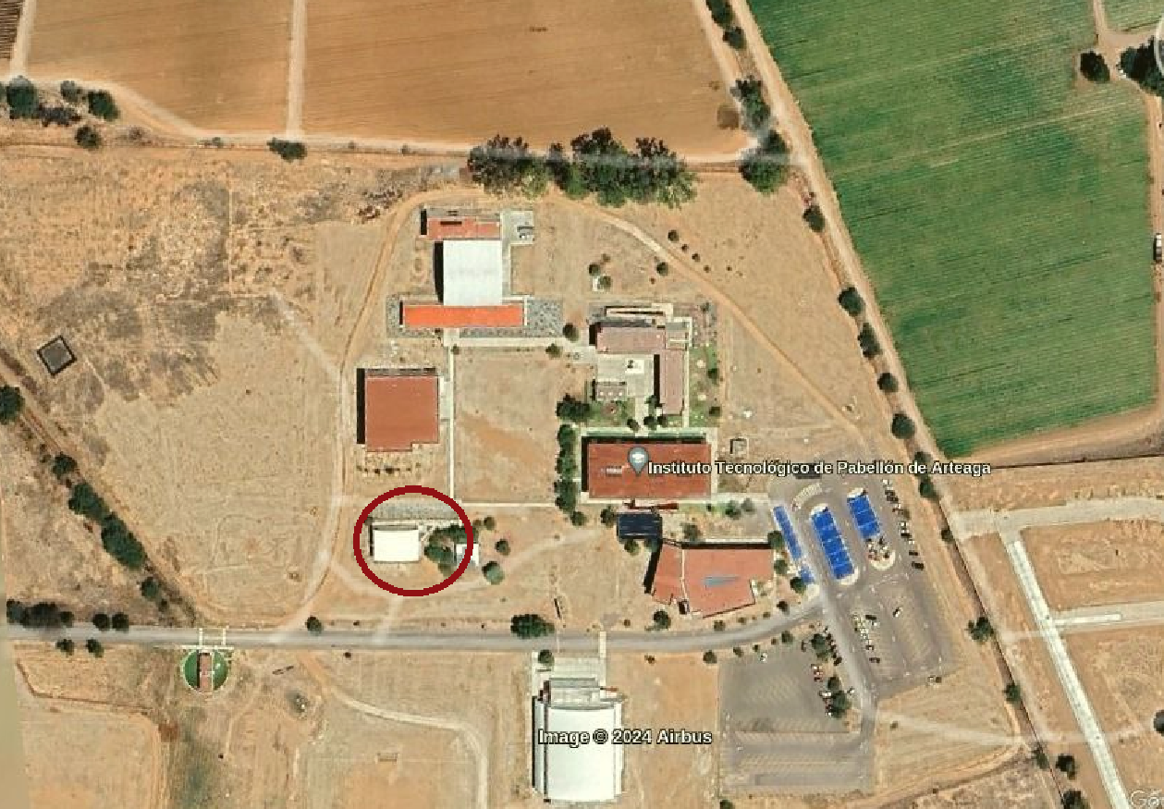

|  |  |  |  |  |
| --- | --- | --- | --- | --- |
| CafeTec |  |  |  |  |
| Adentro |  |  |  |  |
| Redes | 2.4 | Frecuencia | 5 | Frecuencia |
| WifiAdmin | CH1,CH4 | 20MHz |  |  |
| docentes | CH11 | 20MHz |  |  |
| Caseta | CH6 (4) | 40MHz |  |  |
| Students | CH8 | 20MHz |  |  |
| Afuera |  |  |  |  |
| Redes | 2.4 | Frecuencia | 5 | Frecuencia |
| WifiAdmin | CH1,CH4 | 20MHz | CH149 | 40MHz |
| Students | CH8 | 20MHz | CH36,CH157,CH149 | 40MHz |
| Caseta | CH6 (4) | 40MHz |  |  |
| docentes | CH11 | 20MHz | CH151,CH159 | 40MHz |